

API Security Risk Analysis Report

-

,

**PRIYANSHI PATEL**

**Arranged By**

API S API Security Risk Analysis Report

API Security Risk Analysis Report

API Security Risk Analysis Report API S

1. **Introduction**

This report presents an API Security Risk Analysis Performed on a public test API. The purpose of this assessment is to identify common API security issues such as missing authentication , authorization flaws, excessive data expose, and lack of input validation. The testing was conducted using safe and legal methods for learning purpose.

1. **API details**

* API Name : JSONPlaceholder public API
* **Base URL:** https://jsonplaceholder.typicode.com
* **Type:** Public Test REST API
* **Purpose:** Used for testing and learning API requests

**3.Tools Used**

* Postman – API testing
* Browser – API reference
* MS Word / Canva – Report preparation

**4.Methodology**

The API was tested manually using Postman by sending different types of HTTP requests.  
The following security checks were performed:

* Authentication testing
* Authorization testing
* Sensitive data exposure check
* Input validation testing
* Rate limiting observation

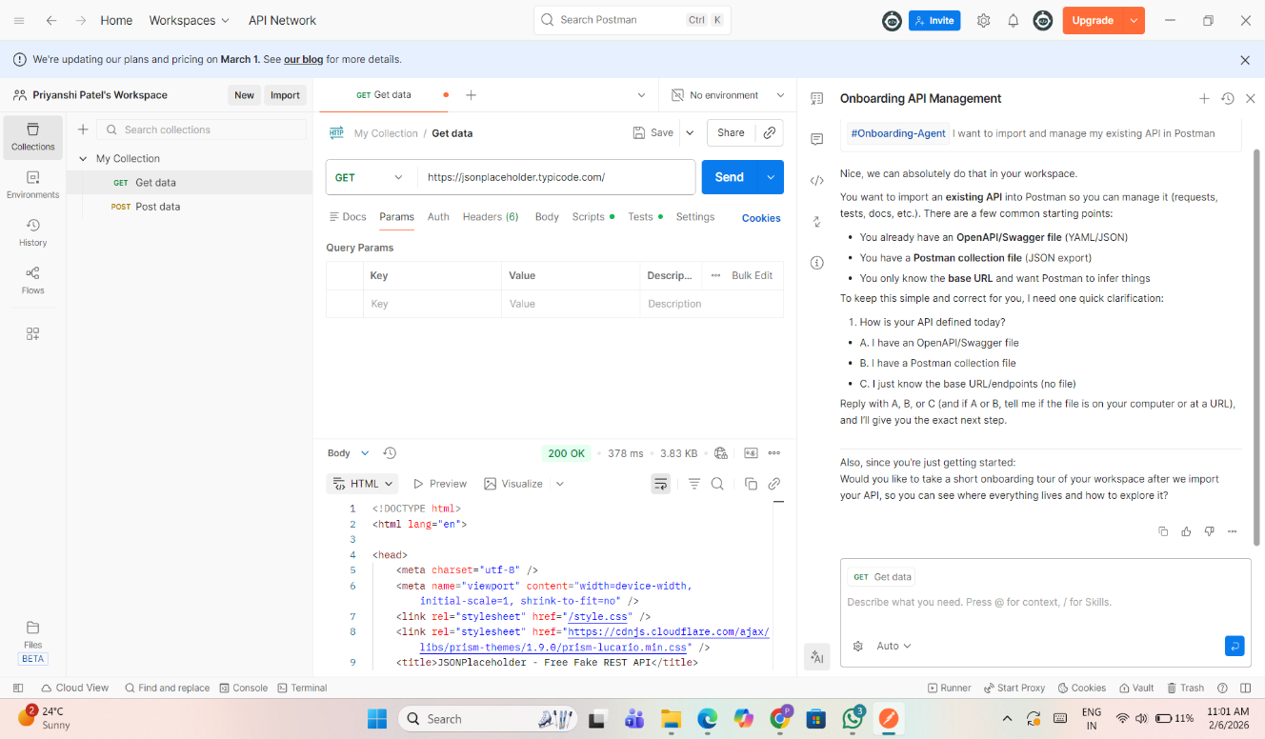

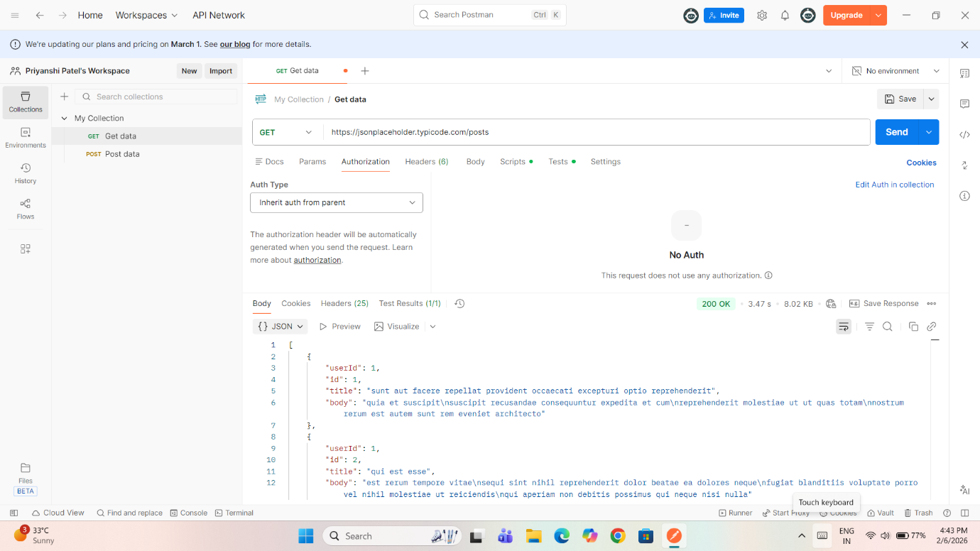

**5.** API Endpoints Tested

| **Method** | **Endpoint** |
| --- | --- |
| GET | /posts |
| GET | /posts/{id} |
| GET | /users |
| POST | /posts |

**6. Findings & Identified Risks**

**6.1 Missing Authentication**

**Description:**  
The API allows access to data without requiring any authentication such as API keys or tokens.

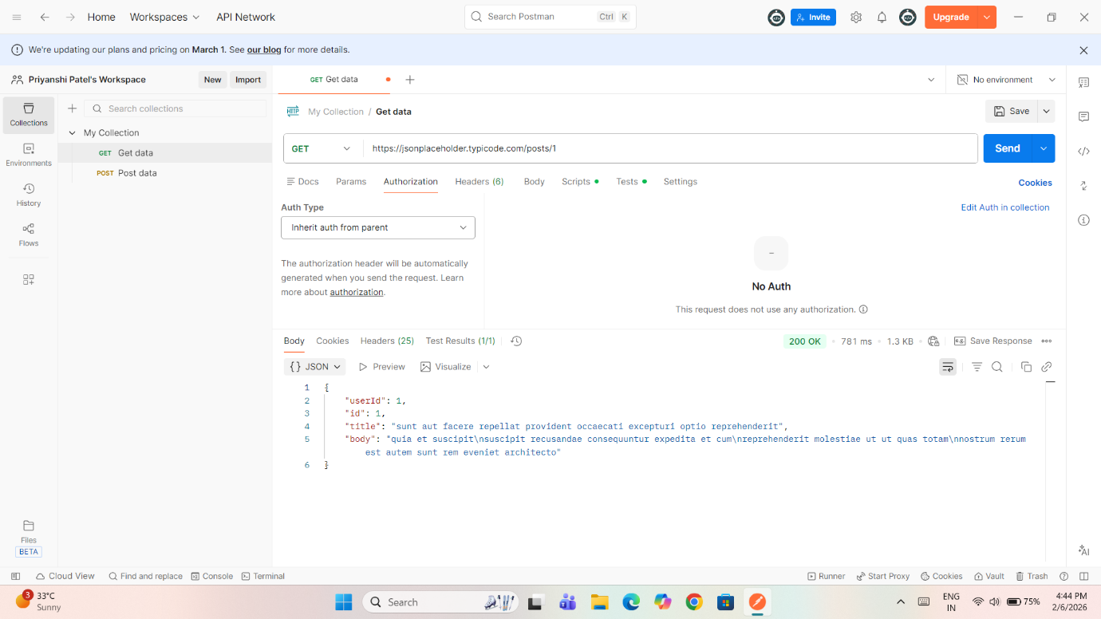

**Impact:**  
Anyone can access the API data, which may lead to unauthorized use.

**Severity:** High

**6.2 Broken Object Level Authorization (BOLA)**

**Description:**  
By modifying the ID value in the URL, different user data can be accessed.

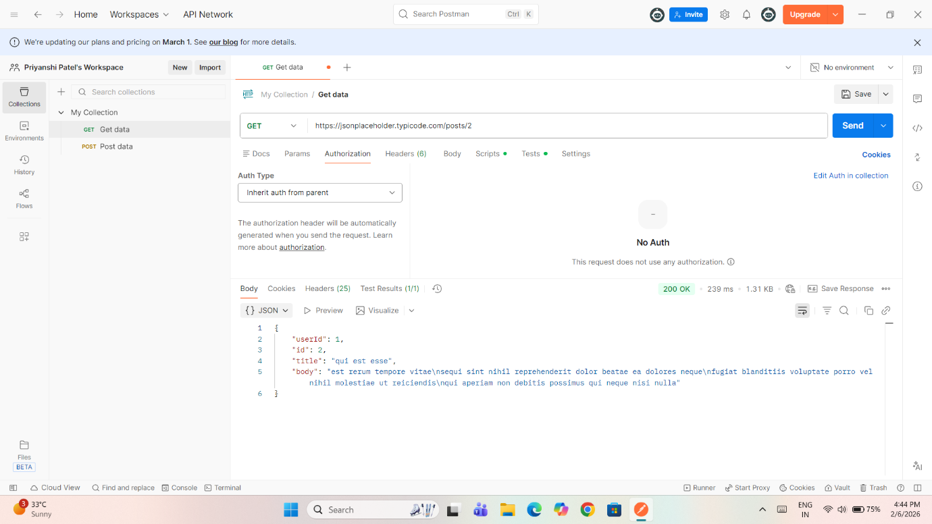

**Impact:**  
Attackers can access or manipulate other users’ data.

**Severity:** High

**Excessive Data Exposure**

**Description:**  
The /users endpoint exposes sensitive information such as email, phone number, and address.

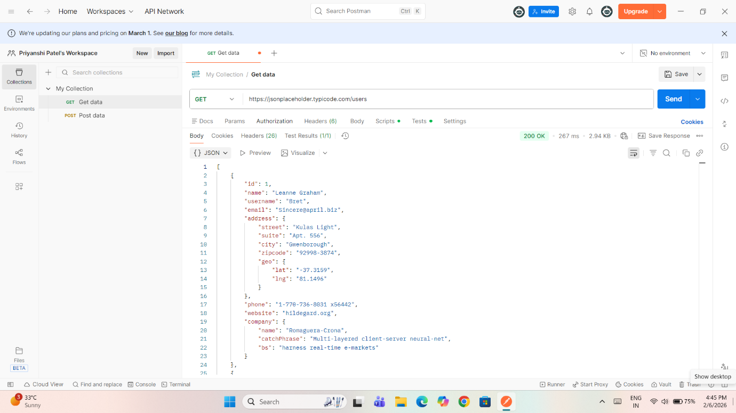

**Impact:**  
Sensitive user data leakage can lead to privacy issues.

**Severity:** Medium

**6.4 Missing Input Validation**

**Description:**  
The API accepts invalid and malicious input without proper validation.

**Impact:**  
This may lead to injection attacks and application compromise.

**Severity:** High

**6.5 No Rate Limiting**

**Description:**  
Multiple requests can be sent continuously without restriction.

**Impact:**  
The API is vulnerable to Denial of Service (DoS) attacks.

**Severity:** Medium

**7. Risk Summary Table**

| **Risk** | **Endpoint** | **Impact** | **Severity** |
| --- | --- | --- | --- |
| Missing Authentication | /posts | Unauthorized access | High |
| BOLA | /posts/{id} | Data exposure | High |
| Excessive Data Exposure | /users | Privacy risk | Medium |
| Missing Input Validation | POST /posts | Injection risk | High |
| No Rate Limiting | All | DoS attack | Medium |

**8. Recommendations**

* Implement **authentication mechanisms** such as JWT or API keys
* Apply **role-based access control** for authorization
* Limit sensitive information in API responses
* Validate and sanitize all user inputs
* Enforce **rate limiting** to prevent abuse

## 9. Conclusion

The API Security Risk Analysis identified multiple security weaknesses that could be exploited if used in a real-world application.  
By implementing proper authentication, authorization, input validation, and rate limiting, the overall security of the API can be significantly improved.